Experiment:8
Aim:
To write a Python program to implement Depth-First Search (DFS) traversal of a graph.
Algorithm:
- Start the program.
- Represent the graph using an adjacency list.
- Create an empty set called visited.
- Start DFS from the selected node.
- Print the node and mark it as visited.
- Visit an unvisited neighbour recursively.
- Continue until no unvisited neighbours remain, then backtrack.
- Stop when all reachable nodes have been visited.
Code:
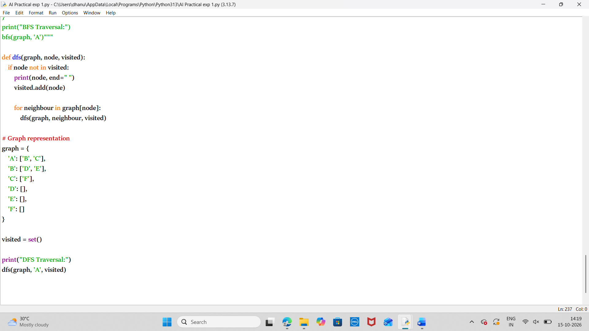
Output:
Result:
Thus the python program to implement the DFS has been executed successfully.

